What Is Machine Learning and Why Is It Important ?

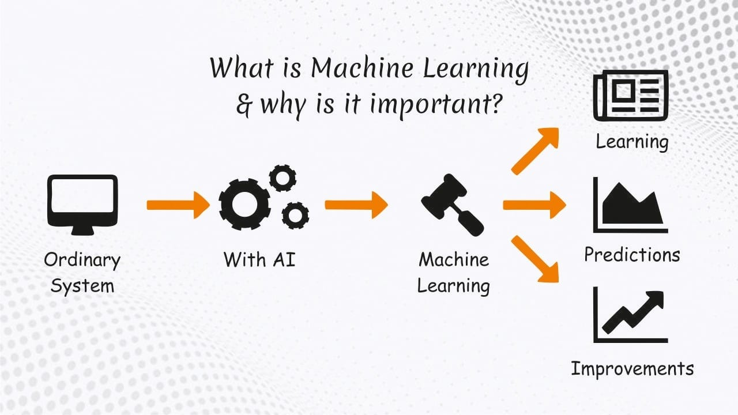

***What is the machine learning ?***

Machine learning (ML) is a type of artificial intelligence (AI) that allows software applications to become more accurate at predicting outcomes. It focus on the computer programs which will access data and use it to find out for themselves.

Why use of algorithms in ML ? because algorithms use a historical data as a input to new predict values. A field of study that gives computers the ability to learn without being explicitly programmed. ML algorithms can incorporate that information to improve its future decision making.

* ***Coined by Arthur Samuel in 1959* **

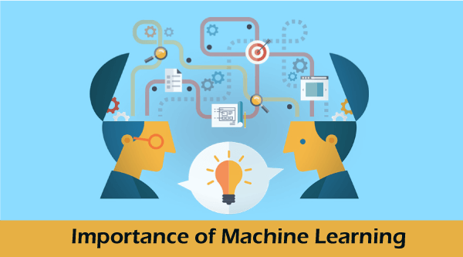

***Why Is It Important ?*** 

Advancements in AI for applications like **Natural Language Processing [NLP] & Computer Vision [CV]** are helping industries like financial services, healthcare, and automotive accelerate innovation, improve customer experience, and reduce costs. Machine learning has applications in all types of industries, including manufacturing, retail, healthcare and life sciences, travel and hospitality, financial services, and energy, feedstock, and utilities.

**Use cases include:**

* **Manufacturing.** Predictive maintenance and condition monitoring
* **Retail.** Upselling and cross-channel marketing
* **Healthcare and life sciences.** Disease identification and risk satisfaction
* **Travel and hospitality.** Dynamic pricing **Financial services.** Risk analytics and regulation
* **Energy.** Energy demand and supply optimization

** Most think about ML :**

#### Easily identifies trends and patterns.

#### Continuous Improvement.

#### Handling multi-dimensional and multi-variety data

* + It is used in various fields.
  + It can handle varieties of data.
  + Scope of advancement for Example. *in forecast, the more data and experience the machine gets the more advanced forecast it will provide.*
  + Considered best for Education like *Smart machine learning will act as a teacher and keep students updated with the current scenario of the world* ☺
  + Machine learning is widely used in stock market trading.
  + application of machine learning rocks in the IT world.
  + **Self-driving cars fro Example*.*** *it is image recognition, voice recognition and predicting the result.*
  + **Reduce time and complexity.**

